**Three Equal Columns**

The following example shows how to get a three equal-width columns starting at tablets and scaling to large desktops. On mobile phones, the columns will automatically stack:

Example:-

<!DOCTYPE html>

<html lang="en">

<head>

<title>Bootstrap Example</title>

<meta charset="utf-8">

<meta name="viewport" content="width=device-width, initial-scale=1">

<link rel="stylesheet" href="https://maxcdn.bootstrapcdn.com/bootstrap/3.4.1/css/bootstrap.min.css">

<script src="https://ajax.googleapis.com/ajax/libs/jquery/3.5.1/jquery.min.js"></script>

<script src="https://maxcdn.bootstrapcdn.com/bootstrap/3.4.1/js/bootstrap.min.js"></script>

</head>

<body>

<div class="container-fluid">

<h1>Hello World!</h1>

<p>Resize the browser window to see the effect.</p>

<p>The columns will automatically stack on top of each other when the screen is less than 768px wide.</p>

<div class="row">

<div class="col-sm-4" style="background-color:lavender;">.col-sm-4</div>

<div class="col-sm-4" style="background-color:lavenderblush;">.col-sm-4</div>

<div class="col-sm-4" style="background-color:lavender;">.col-sm-4</div>

</div>

</div>

</body>

</html>

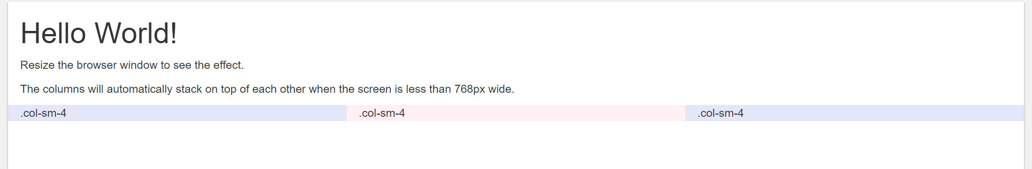

**Three Unequal Columns**

The following example shows how to get a three various-width columns starting at tablets and scaling to large desktops:

Example:-

<!DOCTYPE html>

<html lang="en">

<head>

<title>Bootstrap Example</title>

<meta charset="utf-8">

<meta name="viewport" content="width=device-width, initial-scale=1">

<link rel="stylesheet" href="https://maxcdn.bootstrapcdn.com/bootstrap/3.4.1/css/bootstrap.min.css">

<script src="https://ajax.googleapis.com/ajax/libs/jquery/3.5.1/jquery.min.js"></script>

<script src="https://maxcdn.bootstrapcdn.com/bootstrap/3.4.1/js/bootstrap.min.js"></script>

</head>

<body>

<div class="container-fluid">

<h1>Hello World!</h1>

<p>Resize the browser window to see the effect.</p>

<div class="row">

<div class="col-sm-3" style="background-color:lavender;">.col-sm-3</div>

<div class="col-sm-6" style="background-color:lavenderblush;">.col-sm-6</div>

<div class="col-sm-3" style="background-color:lavender;">.col-sm-3</div>

</div>

</div>

</body>

</html>

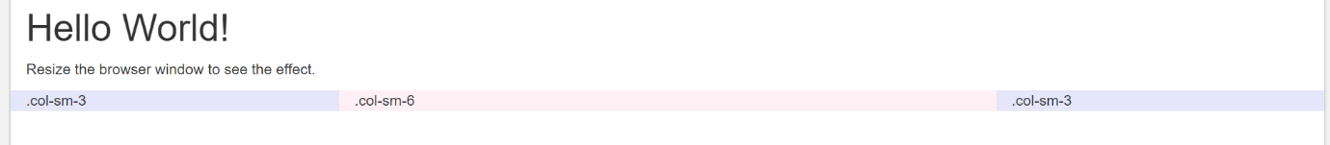

**NOTE:-** Two Equal and Two Unequal Columns are create similarly.

**Two Columns with Two Nested Columns:-**

The following example shows how to get two columns starting at tablets and scaling to large desktops, with another two columns (equal widths) within the larger column (at mobile phones, these columns and their nested columns will stack):

Example:-

<!DOCTYPE html>

<html lang="en">

<head>

<title>Bootstrap Example</title>

<meta charset="utf-8">

<meta name="viewport" content="width=device-width, initial-scale=1">

<link rel="stylesheet" href="https://maxcdn.bootstrapcdn.com/bootstrap/3.4.1/css/bootstrap.min.css">

<script src="https://ajax.googleapis.com/ajax/libs/jquery/3.5.1/jquery.min.js"></script>

<script src="https://maxcdn.bootstrapcdn.com/bootstrap/3.4.1/js/bootstrap.min.js"></script>

</head>

<body>

<div class="container-fluid">

<h1>Hello World!</h1>

<p>Resize the browser window to see the effect.</p>

<div class="row">

<div class="col-sm-8" style="background-color:lavender;">.col-sm-8

<div class="row">

<div class="col-sm-6" style="background-color:lightcyan;">.col-sm-6</div>

<div class="col-sm-6" style="background-color:lightgray;">.col-sm-6</div>

</div>

</div>

<div class="col-sm-4" style="background-color:lavenderblush;">.col-sm-4</div>

</div>

</div>

</body>

</html>

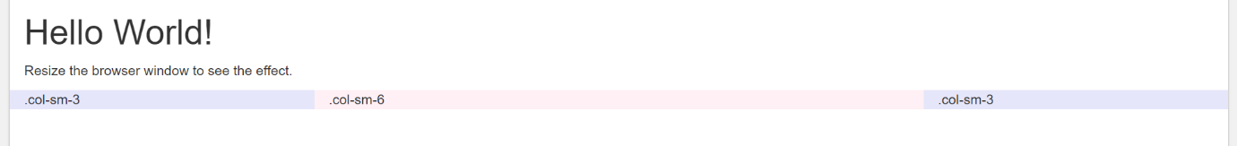

**Mixed:- Mobile and Desktop**

The Bootstrap grid system has four classes: xs (phones), sm (tablets), md (desktops), and lg (larger desktops). The classes can be combined to create more dynamic and flexible layouts.

**Tip:** Each class scales up, so if you wish to set the same widths for xs and sm, you only need to specify xs.

**Example:-**

<!DOCTYPE html>

<html lang="en">

<head>

<title>Bootstrap Example</title>

<meta charset="utf-8">

<meta name="viewport" content="width=device-width, initial-scale=1">

<link rel="stylesheet" href="https://maxcdn.bootstrapcdn.com/bootstrap/3.4.1/css/bootstrap.min.css">

<script src="https://ajax.googleapis.com/ajax/libs/jquery/3.5.1/jquery.min.js"></script>

<script src="https://maxcdn.bootstrapcdn.com/bootstrap/3.4.1/js/bootstrap.min.js"></script>

</head>

<body>

<div class="container-fluid">

<h1>Hello World!</h1>

<p>Resize the browser window to see the effect.</p>

<div class="row">

<div class="col-xs-9 col-md-7" style="background-color:red;">.col-xs-9 .col-md-7</div>

<div class="col-xs-3 col-md-5" style="background-color:lavender;">.col-xs-3 .col-md-5</div>

</div>

<div class="row">

<div class="col-xs-6 col-md-10" style="background-color:lavenderblush;">.col-xs-6 .col-md-10</div>

<div class="col-xs-6 col-md-2" style="background-color:lightgrey;">.col-xs-6 .col-md-2</div>

</div>

<div class="row" style="background-color:lightcyan;">

<div class="col-xs-6">.col-xs-6</div>

<div class="col-xs-6">.col-xs-6</div>

</div>

</div>

</body>

</html>

## Mixed: Mobile, Tablet And Desktop:-

## Example:-

## <!DOCTYPE html>

## <html lang="en">

## <head>

## <title>Bootstrap Example</title>

## <meta charset="utf-8">

## <meta name="viewport" content="width=device-width, initial-scale=1">

## <link rel="stylesheet" href="https://maxcdn.bootstrapcdn.com/bootstrap/3.4.1/css/bootstrap.min.css">

## <script src="https://ajax.googleapis.com/ajax/libs/jquery/3.5.1/jquery.min.js"></script>

## <script src="https://maxcdn.bootstrapcdn.com/bootstrap/3.4.1/js/bootstrap.min.js"></script>

## </head>

## <body>

## <div class="container-fluid">

## <h1>Hello World!</h1>

## <p>Resize the browser window to see the effect.</p>

## <div class="row">

## <div class="col-xs-7 col-sm-6 col-lg-8" style="background-color:red;">.col-xs-7 .col-sm-6 .col-lg-8</div>

## <div class="col-xs-5 col-sm-6 col-lg-4" style="background-color:lavender;">.col-xs-5 .col-sm-6 .col-lg-4</div>

## </div>

## <div class="row">

## <div class="col-xs-6 col-sm-8 col-lg-10" style="background-color:lavenderblush;">.col-xs-6 .col-sm-8 .col-lg-10</div>

## <div class="col-xs-6 col-sm-4 col-lg-2" style="background-color:lightgrey;">.col-xs-6 .col-sm-4 .col-lg-2</div>

## </div>

## <div class="row" style="background-color:lightcyan;">

## <div class="col-xs-6">.col-xs-6</div>

## <div class="col-xs-6">.col-xs-6</div>

## </div>

## </div>

## </body></html>

## 

## Clear Floats

## Clear floats (with the .clearfix class) at specific breakpoints to prevent strange wrapping with uneven content:

## Example:-

## <!DOCTYPE html>

## <html lang="en">

## <head>

## <title>Bootstrap Example</title>

## <meta charset="utf-8">

## <meta name="viewport" content="width=device-width, initial-scale=1">

## <link rel="stylesheet" href="https://maxcdn.bootstrapcdn.com/bootstrap/3.4.1/css/bootstrap.min.css">

## <script src="https://ajax.googleapis.com/ajax/libs/jquery/3.5.1/jquery.min.js"></script>

## <script src="https://maxcdn.bootstrapcdn.com/bootstrap/3.4.1/js/bootstrap.min.js"></script>

## </head>

## <body>

## <div class="container-fluid">

## <h1>Hello World!</h1>

## <div class="row">

## <div class="col-xs-6 col-sm-3" style="background-color:lavender;">

## Column 1<br>

## Resize the browser window to see the effect. Also try to remove the div clearfix line and see what happens.

## </div>

## <div class="col-xs-6 col-sm-3" style="background-color:lavenderblush;">Column 2</div>

## <!-- Add clearfix for only the required viewport -->

## <div class="clearfix visible-xs"></div>

## <div class="col-xs-6 col-sm-3" style="background-color:lightcyan;">Column 3</div>

## <div class="col-xs-6 col-sm-3" style="background-color:lightgray;">Column 4</div>

## </div>

## </div>

## </body>

## </html>

## 

## Offsetting Columns

## Move columns to the right using .col-md-offset-* classes. These classes increase the left margin of a column by * columns:

## Example:-

## <!DOCTYPE html>

## <html lang="en">

## <head>

## <title>Bootstrap Example</title>

## <meta charset="utf-8">

## <meta name="viewport" content="width=device-width, initial-scale=1">

## <link rel="stylesheet" href="https://maxcdn.bootstrapcdn.com/bootstrap/3.4.1/css/bootstrap.min.css">

## <script src="https://ajax.googleapis.com/ajax/libs/jquery/3.5.1/jquery.min.js"></script>

## <script src="https://maxcdn.bootstrapcdn.com/bootstrap/3.4.1/js/bootstrap.min.js"></script>

## </head>

## <body>

## <div class="container-fluid">

## <h1>Offsetting Columns</h1>

## <p>Resize the browser window to see the effect.</p>

## <div class="row" style="background-color:lavender;">

## <div class="col-sm-5 col-md-6" style="background-color:lightgray;">.col-sm-5 .col-md-6</div>

## <div class="col-sm-5 col-sm-offset-2 col-md-6 col-md-offset-0" style="background-color:lightcyan;">.col-sm-5 .col-sm-offset-2 .col-md-6 .col-md-offset-0</div>

## </div>

## </div>

## </body>

## </html>

## 

## Order Classes

## Use .order- classes for controlling the ****visual order**** of your content. These classes are responsive, so you can set the order by breakpoint (e.g., .order-1.order-md-2). Includes support for 1 through 12 across all five grid tiers.

## Example:-

<div class="container">

<div class="row">

<div class="col order-last">

First in DOM, ordered last

</div>

<div class="col">

Second in DOM, unordered

</div>

<div class="col order-first">

Third in DOM, ordered first

</div>

</div>

</div>

## 